**Bootstrap**

<!doctype html> <html>

<head>

<meta charset=”utf-8”>

<meta name=”viewport” content=”width=device-width, intial-scale=1”>

<link rel=”stylesheet” type=”text/css” href=”css/bootstrap.min.css”> </head>

<body>

…………………..

<script type=”text/javascript” src=”js/bootstrap.min.js”></script>

<script type=”text/javascript” src=”js/jquery.js”></script>

</body>

</html>

**Grid system:**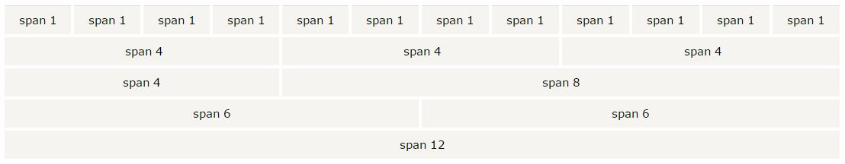

xs-for phones

sm-for tablets

md-for desktops

lg- for large screens

|  |  |
| --- | --- |
| <div class=”container”>  <div class=”row”>  <div class=”col-md-6 *well*”>col6</div>  <div class=”col-md-6 well”>col6</div>  </div>  </div> | <div class=”row”>  <div class=”col-md-3 well”>col6</div>  <div class=”col-md-9 well”>col6</div>  </div>  total have to be 12 or below |

**Container:** container is used to set the content's margins dealing with the responsive behaviors

**Jumbotron:** a big box for getting extra attention

<div class=”jumbotron”></div> //it come inside or outside container

**Page header:** a section divider. It adds a horizontal line under the heading.

<div class=”page-header”></div> //comes inside or outside container

**Button:** default, primary, success, info, warning, danger, link

**Table:**

<table class="table">

<tr> <th>s.no</th><th>name</th>

<tr> <td class="success">1 sucess</th><td class="danger">rajesh danger</td>

<tr> <td class="active">2 active</td><td class="info">arun info</td></table>

**Forms:** vertical form, horizontal form, inline form

**Alert:** class=”alert alert-sucess” info, warning, danger,

**Badges:** <span class=”badge”>notification 2k</span>

**Labels:** <span class=”label label-default”>this is label<span>

**Panels:** <div class=”panel panel-primary”><div class=”panel-heading”>it is panel</div></div>

**Pagination:**webpages contains lot of web pages in same page

**Pager:** same like pagination just it has oval shape

**Image shapes:** rounded, thumbnail, responsive, etc

**Glyphicon:**icon fonts

Progress Bar:

Listgroups: